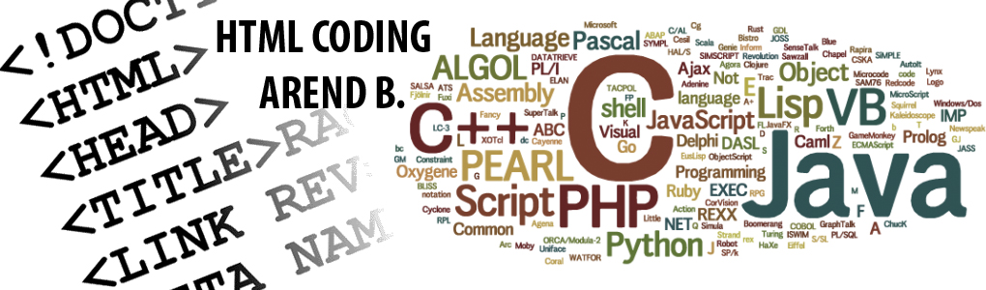
HTML Coding
Why HTML coding is vital for designing a website?
HTML is a language for describing webpages using ordinary text. It's not a complex programming language. Every webpage is actually a HTML file. HTML is the hidden code that helps us communicate with others on the world wide web.
When writing HTML you add tags to the text in order to create the structure. These tags tell the browser how to display the text or graphics in the document. For example, the following document has a simple layout (structure). Notice there are three major parts: a heading, two paragraphs and a list.
Algorithm | HTML Coding
HEADING  My PBL  PARAGRAPH  My name is Arend….  PARAGRAPH  There are 2 reasons I like Coding  LIST  - I love programming  - I love computer | <html>  <head>  <title> </title>  </head>  <body>  <h1> My PBL </h1>  <p> My name is Arend….  </p>  <p>There are two reasons I like to swim:</p>  <ul>  <li> I love programming</li>  <li> I love computer</li>  </ul>  </body>  </html>
My Website | My Video

